The Learning objective is: To learn pairs of near homophones.
Near homophones are two or more words that have different spellings and meanings and sound very much alike, but not exactly.
Activity 1 - Practise these words using the Look Read Cover Write Check method, writing them in your spelling homework book 5 times. We are expecting your very best handwriting too!
Activity 2 – To help you to understand the words better, use each of the words in a sentence. Doing this will help you to use the word in the correct context.
For example: I went there for my birthday.
It’s their turn to use the football pitch.
They’re going to get wet without an umbrella.
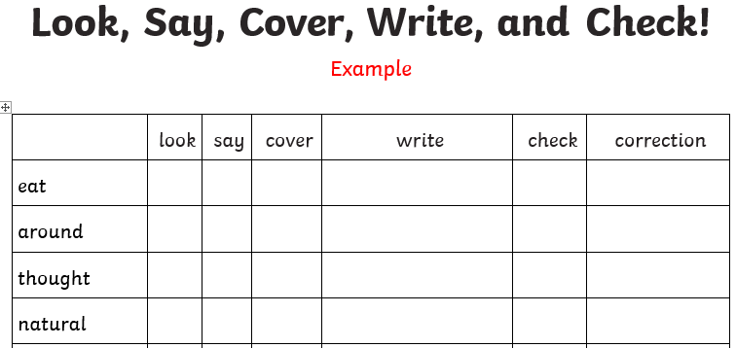
On Friday you will be tested on all of the words below. You are expected to get the words in your spelling group correct as well as the statutory words and you can attempt the rest.
Purple | Green | Yellow | Statutory words
their – there – they’re | whose – who’s | accept – except | bicycle
were – where – we’re | grate - great | affect – effect | centre
are - our | weather - whether | medal – meddle | century

