Year 4 | Autumn 1 |  |  | States of Matter |  |  | All matter is in the solid, liquid or fast state at room temperature but may change state if warmed or cooled
matter: All materials in the universe that exist as a solid, liquid or gas |  | substance: is a type of matter such as water (liquid) wood (solid) or oxygen (gas) |  |  | solid: made up of particles tightly packed together which keep their shape |  |  | liquid: can be poured and do not keep their shape. The particles move more freely |  | gas: gases are usually invisible and the particles move very freely in all directions
water vapour: A gas formed when water is boiled at 100°C |  | evaporation: The change of state from a gas to a liquid (through heating) |  |  | condensation: the process in which gas is cooled into a liquid |  |  | precipitation: release of water from sky as rain or snow |  | particle: tiny bits matter that make up solids, liquids and gases
Celsius: measurement of temperature  (water freezes at 0° C and boils at 100°C) |  | boiling point: The temperature in which a liquid becomes a gas |  |  | melt/melting: process of changing a sold into a liquid |  |  | reversible: A change that can go backwards |  | freeze/freezing: the process in which a liquid turns into a solid
Statutory words |  | average | category |  | explanation | frequently |  | temperature | occur | equipment | variety
What is matter?  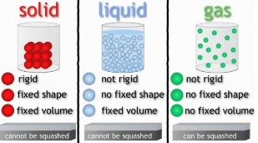 |  | How do materials change their state of matter? |  |  |  |  |  |  |  | 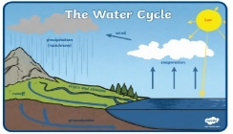  What is the role of evaporation in the Water cycle?
 |  | 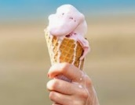  What is melting and freezing? |  |  | What is evaporation and condensation? |  |  | What is a reversible and irreversible change?
Every material in the universe can exist in 3 states: solid, liquid or a gas. These are called ‘matter’.  Solid particles stay in one place and can be held  Solids keep their shape and do not flow like liquids  Solids always take up the same amount of space.  Solids can be cut or shaped but they are not always hard, for example: blue tac and play doh are solids.  Liquids can flow or be poured easily.  They are not easy to hold.  Liquids change their shape depending on the container they are in. Even when liquids change their shape, they always take up the same amount of space. Their volume stays the same.  -Gases are often invisible -They do not have a fixed shape and -they spread out change their shape |  | The state a material depends on its temperature.  Melting is the process of changing a solid into a liquid. When an ice-cream is heated from the sun it begins to melt. This is because the particles begin to move faster. Different substances melt at different temperatures. This is called a melting point.  Freezing is the process of changing a liquid into a solid. Freezing happens when liquid water) is cooled below 0°C.. Different substances freeze at different temperatures. This is called a freezing point.  Water is in its solid state (ice) at 0°C.  It exists as liquid water between 0°C and 100°C.  Above 100°C it exists in the gas state (steam or water vapour). |  |  | 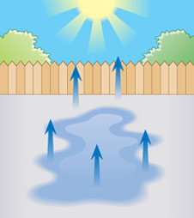  Evaporation is the process of changing a liquid into a gas. Water turns into water vapour when it is heated. This happens very quickly when the water is hot like in a kettle, but it can also happen slowly like a puddle evaporating in the warm air.  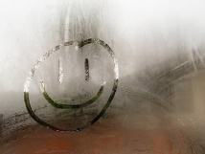  Condensation is the process of changing a gas into a liquid. When water vapour or steam cools down it turns back into water. The water vapour in the air cools when it touches a cold surface (like a window). |  |  | A reversible change is a change that can be changed back again. For example, if an ice-cube is melted it becomes water but we can freeze it again to become an ice-cube so it can return to its original state. Melting and heating are examples of reversible changes.  An irreversible change is a change that cannot be changed back again. For example, if a cake mixture is baked it becomes a cake and we cannot turn it back into a mixture. The change is irreversible because a chemical reaction has taken place. Burning or mixing a liquid with bicarbonate of soda are examples of irreversible changes  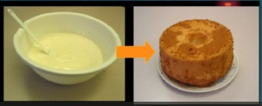  . |  | Water on Earth is constantly moving. It is recycled over and over again. This recycling process is called the water cycle. 1. Water evaporates into the air: The sun heats up water on land, and turns it into water vapour. The water vapour rises into the air. 2. Water vapour condenses into clouds: Water vapour in the air cools down and changes back into tiny drops of liquid water, forming clouds. 3. Water falls as precipitation: The clouds get heavy and water falls back to the ground. 4. Water returns to the sea: Rain water runs-off the land and collects in lakes or rivers, which take it back to the sea. The cycle starts all over again.

