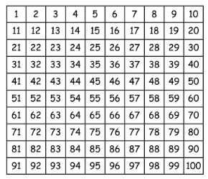
Homework:
Hand out date: Friday 11th September
Due in date: Friday 18th September

Task One: Arithmetic Task
LO - count forwards and backwards in steps of 2.
Using the hundred square, choose a different starting number each time and count forwards and backwards in steps of 2.

Task Two: complete the worksheet provided and bring back to school ready to go through and mark in class on a Friday.
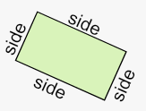
LO – count sides of 2d shapes

Video link – https://vimeo.com/428007654

