Homework:
Hand out date: Friday 18th September
Due in date: Friday 25th September

Task One: Arithmetic Task
LO - partition 3 digit numbers
Think of a 3-digit number. Partition the number and mentally say the addition number sentence. Repeat.
For example:
167 = 100 + 60 + 7
672 = 600 + 70 + 2
Task Two: complete the worksheet provided and bring back to school ready to go through and mark in class on a Friday.
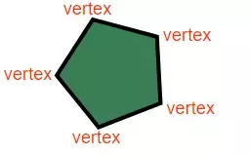
LO – count vertices (vertex) of 2d shapes
Video link – https://vimeo.com/428007654
Please note the video is the same as last week however todays focus is vertices (vertex).
