The Learning objective is: spell words with the suffix –ed where the root word ends in a consonant and a ‘y’ and the ‘y’ becomes an ‘i’.

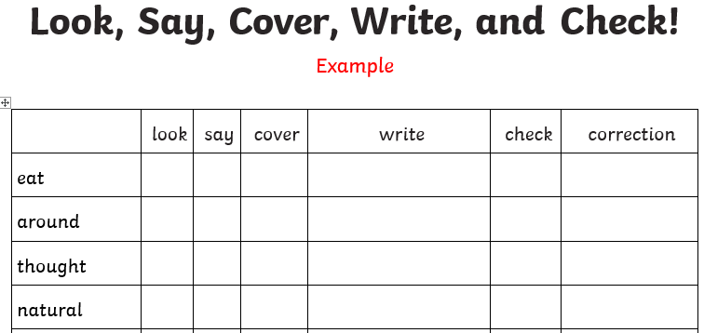
Activity 1 - Practise these words using the Look Read Cover Write Check method, writing them in your spelling homework book 5 times. We are expecting your very best handwriting too!
Activity 2 – Choose 2 of the words from your colour and use them in a sentence.
For example:
At the weekend we had bacon and fried eggs on toast.
On Friday you will be tested on all of the words below. You are expected to get the words in your spelling group correct as well as the statutory words and you can attempt the rest.
Purple | Green | Yellow | Statutory words
cried | married | replied | although
tried | worried | hurried | answer
fried | copied | studied | appear
denied | carried | emptied | arrive

Challenge: can you think of any other –ed words that follow this rule?

