Homework:
Hand out date: Friday 2nd October
Due in date: Friday 9th October

Task One: Arithmetic Task
LO - count forwards in steps of 5.
In class this week, we have been looking at counting in steps of 5.
Choose a multiple of 5 and count forwards. Keep changing your starting number.
Helpful hints:
- All multiples of 5 end in a 0 or a 5.
- When counting from 0 they follow the pattern 0, 5, 0, 5 etc.

Task Two: complete the worksheet provided and bring back to school ready to go through and mark in class on a Friday.
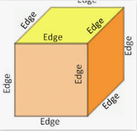
LO – count edges on 3d shapes
Video link –
https://vimeo.com/428007789
Please note the video is the same as last week. This week we are focusing on edges.
