The Learning objective is: spell words with the suffix –ing where the root word doesn’t change.

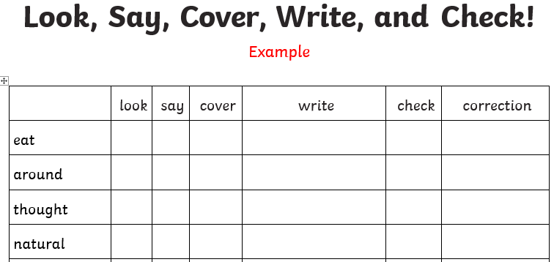
Activity 1 - Practise these words using the Look Read Cover Write Check method, writing them in your spelling homework book 5 times. We are expecting your very best handwriting too!

Activity 2 – Choose 2 of the words from your colour and use them in a sentence.
For example:
I am working really hard on my spelling homework.
On Friday you will be tested on all of the words below. You are expected to get the words in your spelling group correct as well as the statutory words and you can attempt the rest.
Purple | Green | Yellow | Statutory words
working | sweeping | boasting | believe
looking | starting | doubting | bicycle
pushing | folding | dreaming | breath
calling | handing | jumping | build

