Year 3 |  |  |  | R.E Autumn 2 |  |  |  | Christianity – What are God’s rules for living?
beliefs, teachings and sources |  |  |  | practices and ways of life |  |  |  | forms of expression
Key Vocabulary
rule – an instruction that tell you what you are allowed to do and what you are not allowed to do. |  | Commandment - behaviour that people should follow (obey). |  |  |  | Old Testament - is the first part of the Bible (before Jesus was born). |  |  |  | Prophet - a person regarded as an inspired teacher of the will of God.
Christian - someone who follows the teachings of Jesus Christ. |  | Jew- a person who believes in and practises the religion of Judaism. |  |  |  | Torah - In the Jewish religion, the Torah is the first five books of the Old Testament of the Bible, regarded collectively. |  |  |  | Moses – a prophet who lived before Jesus was born.
Statutory Words | believe |  | important |  | guide |  | promise |  | appear |  | different
What Are The 10 Commandments? Are They Your 10 Commandments?  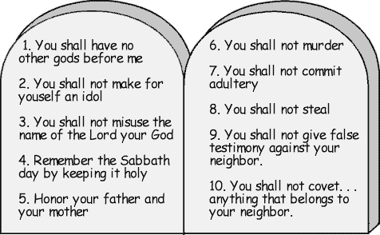  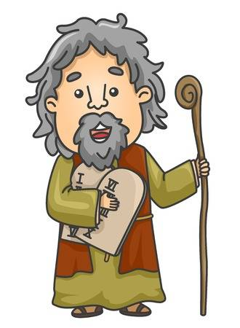 |  |  |  |  |  | What Do The 10 Commandments Teach Us About God and The Way To Live?  What was / is He trying to achieve by encouraging people to follow these rules?  Why did God feel that there needed to be a set of rules for the world?  Because these rules were made up by God, what clues do they give us about God?  e.g. What do they tell us about the nature of God? What God is like?
Did you know?

Christians believe there is a set of rules for the world
which they are commanded to follow.

God revealed the 10 commandments to Moses on a mountain.

The story of Moses and the 10 commandments can be found in the Old Testament.

Jews also follow these rules as they were originally given to Jews and they are found in the Torah (as part of The Torah contains part of The Old Testament)

