Year 3 SCIENCE Pushes and Pulls: Changes in the movement of an object require a net force acting on it: Forces and Mechanisms
forces: Is a push or pull on an object. | magnetic: Objects that are pulled by magnets. | repel: To push away | attract: To pull closer
magnet: A material or object that pulls objects that contain iron and some other materials. | magnetic field: An area around an object in which there is a magnetic force. | friction: A force that holds back the movement between two touching objects. The force acts in the opposite direction to the way an object wants to slide. | horseshoe magnet: Magnet in the shape of a horseshoe.
magnetic poles: Area at the end of each magnet where the magnetic field is strongest. | magnetism: Is a force that can attract (pull closer) or repel (push away) objects that have a magnetic material like iron inside them. | gravity: The force that attracts two objects with mass towards each other. | bar magnet: Magnet in the shape of a bar
What are magnets? | What are Magnetic poles? | How do things move on different surfaces? | What is a force?
Magnets are objects that pull or push things with an invisible force called magnetism, which pulls on some metals such as iron and nickel. Objects such as paperclips are magnetic because they have these metals inside them.  A bar magnet and a horseshoe magnet are two of the different types of magnets. Magnets have different strengths which means that some can attract magnetic objects at a further distance.  Objects that are pulled by magnets are said to be magnetic. Objects that are not pulled by magnets are said to be non-magnetic.  A magnetic force can act at a distance. This means that an object does not need to be touching the magnet for it to be pulled towards it.  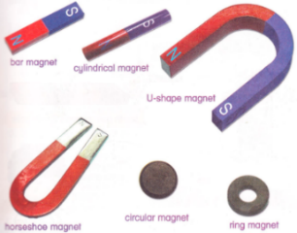 | The ends of a magnet are called its poles. One end is called the north pole, the other end is called the south pole.  When two magnets are close, they create pushing or pulling forces on one another.  These forces are strongest at the ends of the magnets.  When two magnets are put together, the North and North and South and South poles repel each other. Whereas, a South and North pole attract.  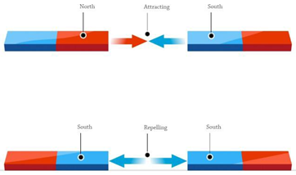 | Friction is a force that holds back movement between two objects as the force acts in the opposite direction.  It is easier to push or pull something along a smooth surface than a bumpy surface. Smooth surfaces have less friction then bumpy surfaces.  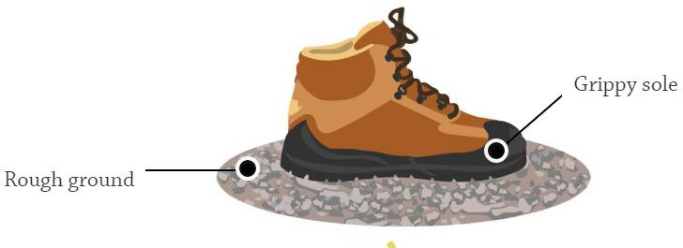  It would therefore be easier for you to move your foot across an icy surface rather than a rough one like the ground.  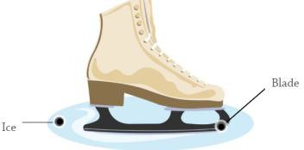 | A force can cause something to speed up, slow down, change shape or change direction. It is a push or pull that causes movement.  For some forces to act, there needs to be direct contact (e.g. opening a door, pushing a swing).  Some forces can act at a distance e.g. magnetism. The magnet does not need to touch the object that it attracts.  