Year 3 |  |  |  | R.E Autumn 1 |  |  |  |  | Christianity – The local church
beliefs, teachings and sources |  |  |  | practices and ways of life |  |  |  |  | forms of expression
Key Vocabulary
a church – a building where Christians meet to pray, read the Bible and worship God. |  | church school – a school that is supported by The Church of England (or another church). |  |  |  | Church of England – a community of churches across the country with similar beliefs about God and worship. |  |  |  | font – a special pool in a church that is filled with water for baptisms.
symbol– different signs, pictures or logos that have significance or important meaning. |  | Bible - the holy book for Christians. |  |  |  | cross – a religious symbol to remind Christians that Jesus died to save them. |  |  |  | altar – a special table at the front of a church for ceremonies and celebrations.
Christian – someone who believes in God and follows the teaching of Jesus Christ. |  | local – close by or in the community. |  |  |  | Vicar – the person who leads the worship and ceremonies at a church (also known as a priest). |  |  |  | belong – to be a part or a member of a group or organisation, and to feel valued by it.
Statutory Words | believe |  |  |  | important |  |  | different |  |  | guide
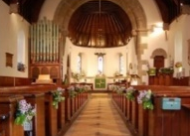  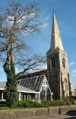  What is the Church? |  |  | What makes my school a church school?  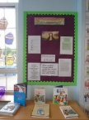  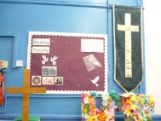 |  |  |  | What happens in church?  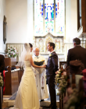  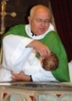  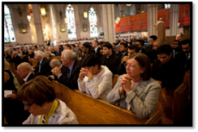 |  |  | What does it mean to belong?  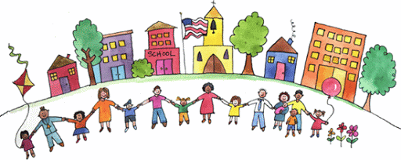
Did you know?  The church is God’s house where Christians go to pray, read the bible and worship God.  The church is also the people, not just the building. Many Christians go to church to praise God together as a group and to build friendships.  Christians worship involves praising God in music and speech, readings from the Bible, prayers and sermons.  Church buildings throughout the world vary hugely! Many churches have a bell tower which is rung before a service to let people know it is time for worship.  Crosses often appear in Christian churches to represent that Jesus died on the cross to save us.  Colourful stained glass windows often appear in churches to represent Jesus’ life. Candles are common in churches as they represent Jesus as the light of the world. |  |  | Did you know?  We have symbols of the cross around our school to show that we are a church school.  During collective act of worship, we listen to readings from the Bible to learn more about God and his teachings. We sing songs as a way of worshipping God together.  Each classroom has a prayer corner displayed with bible quotes and reflective questions. Bibles are also found in every prayer corner for children to use.  Before lunch, a daily lunch time prayer is said thanking God for food and water. |  |  |  | Did you know?  The role of a Vicar is to carry out church services such as weddings and baptise children and people.  The Vicar stands at the altar during services and ceremonies and wears special clothes called vestments.  The Vicar shares bread and wine with Christians during services. The wine is used to remember Jesus’ blood and the bread to remember Jesus’ body when he was crucified on the cross.  A baptism is the way that Churches officially welcome people into the Christian family. The Vicar pours water from the font over the head of the baby or person being baptised.  A wedding is a special ceremony where a bride and groom come together to declare their love for one another in front of God, family and friends. |  |  | Did you know?  A community is a group of people who live close together and have shared interests or beliefs.  People belong to different communities because of their shared interests/beliefs or because they want some company or support.  An inclusive community is a place where each person shares a sense of belonging with its other members. Members in an inclusive community should feel safe and respected.  We are all part of the Holy Trinity community. We are also part of God’s community as we are a church school.

