Year 3 |  |  |  | R.E Autumn 2 |  |  |  | Which Nativity Character are you?
beliefs, teachings and sources |  |  |  | practices and ways of life |  |  |  | forms of expression
Key Vocabulary
Bible: the holy book for Christians. |  | Nativity Story: the story of Jesus the son of God being born as a baby. |  |  |  | Christmas: a Christian celebration of the birth of Jesus that happens every year. |  |  |  | Mary: the mother of Jesus when he was born on earth.
Shepherd: a person who tends sheep. |  | Angel: a spiritual being who is a messenger of God. |  |  |  | Wise Men: Kings who visited baby Jesus. |  |  |  | announcement: a public statement about something that has happened or is happening.
Joseph: Mary’s husband. |  | manger: an open box from which cattle and horses feed from. |  |  |  | stable: a building in which horses are kept. |  |  |  | innkeeper: a person who owns an inn where travellers can seek lodgings.
Statutory Words | appear |  | believe |  | earth |  | guide |  | promise |  | remember
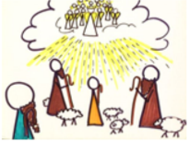  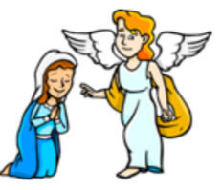  Why were the Angels important in the Nativity story? |  | 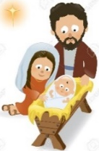  Who were Mary and Joseph? |  |  |  | 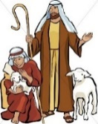  What was the role of the Shepherds in the nativity story? |  |  |  | Who was King Herod and what did he do?  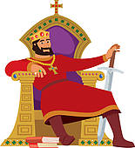  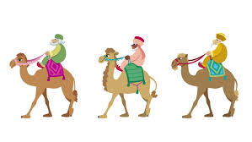
Did you know?  The Angel Gabriel visited Mary in Nazareth to tell her the “good news” that she was going to give birth to a baby.  The angel told Mary that the baby would be named Jesus and will be the son of God. The Angel Gabriel also told Mary that she was to marry Joseph.  God chose Mary to be Jesus’ mother because God was pleased with her.  The Angel Gabriel appeared to Joseph in a dream and said that Mary would have a baby who would be named Jesus which means 'Saviour' because he would save people. The angel told Joseph that he should marry Mary.  A whole group of angels went to the shepherds in their field to tell them the “good news” that Jesus, the Son of God had been born and that they should go and visit him. |  | Did you know?  Mary was the mother of Jesus when he was on earth. God sent an angel to Mary to tell her that God was pleased with her and that she would give birth to the Son of Most High.  Joseph was a hard working carpenter who was told by an angel that he should marry Mary and that she was truly carrying the Son of God.  Joseph needed to know what part he would play in God’s amazing plan.  Mary and Joseph travelled to Bethlehem on a donkey to be counted in the census.  When they arrived, they searched for a place to stay but there was no room in any of the inns. An innkeeper offered Mary and Joseph a stable where Jesus would be born.  Mary and Joseph were chosen by God because they were kind hearted, ordinary people who led a good life by following God’s rules. |  |  |  | Did you know?  Shepherds are people who take care of sheep and move them from one place to another.  One night, some shepherds were in the fields nearby watching their sheep when an angel appeared. The angel told them that the Son of God would be born in David’s town. They were told that they would find the baby wrapped in clothes lying in a manger.  When the shepherds visited baby Jesus, they told Mary and Joseph what the angels had said about this child. Everyone was amazed when the shepherds said that Jesus was the Son of God.  Then the shepherds went back to  their sheep, praising God and thanking him for everything that they had seen and heard.  Jesus said he was like a shepherd because he guides his people and looks after them like a shepherd would care for his sheep. |  |  |  | Did you know?  At the time of Jesus’ birth, the country was under the rule of King Herod. He was a selfish and evil king and wasn’t well liked.  King Herod was worried that he would lose his Kingdom to the King of the Jews, Jesus, and therefore wanted to kill him.  He told the wise men to find where Jesus was and to let him know where to find him so that he could go and worship him.  When the wise men went to see baby Jesus, they presented him with gifts of gold, frankincense and myrrh.  The wise men did not tell Herod where to find Jesus and did the right thing by keeping it a secret.

