Year 3: The Natural World: Fossils are formed over millions of years and appear in some rocks: Rocks and soils.
Rocks: Are made up of grains that are packed together | Mineral: Are solid chemical substances that occur naturally – examples include: diamond, quartz, gypsum. Each grain that makes up the rock is made from a mineral. | Pressure: Pressure is force that you produce when you press hard on something. | Petrologist: Someone who studies rocks | Preserved: stays in its original state.
Magma: Liquid rock inside a volcano | Molten rock: A rock that has been reduced to liquid through heating. | Fossils: the remains or impression of a prehistoric plant or animal embedded in rock | Palaeontologist: A person who studies fossils. | Mary Anning: a famous palaeontologist and fossil collector.
Soil: A mixture of tiny particles of rocks, organic matter from animals and plants, as well as air and water | Weathering: Rocks that have been broken down by the weather, e.g. ice, water, frost, wind, heat | Non-permeable: Not allowing water to pass through it | Permeable: Allowing water to pass through it
How can rocks be compared and grouped? | What are the different types of rock? | What is soil made from? | What are fossils? | What are permeable and non-permeable rocks?
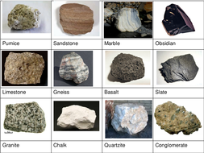  Rocks can be compared and grouped in many ways. They can be compared by their colour, patterns, textures, hardness and the particles within them.  For example, some rocks can be smooth or rough, some may be dull or shiny and some may contain crystals and some may not. | Rocks are made of one or more minerals. There are three main types of rock based on the way the rock was formed.  • Metamorphic Rocks - Metamorphic rocks are formed by great heat and pressure. They are generally found inside the Earth's crust where there is enough heat and pressure to form the rocks. Metamorphic rocks are often made from other types of rock.  • Igneous Rocks - Igneous rocks are formed by volcanoes. When a volcano erupts, it spews out hot molten rock called magma or lava. The magma then cools down and hardens either above of underground. This hardened magma or lava is called igneous rock.  • Sedimentary Rocks – sedimentary rocks are formed by years and years of sediment (small pieces) compacting together and becoming hard. Streams and rivers carry lots of small pieces of rocks and minerals to larger bodies of water. These pieces will settle at the bottom and over a very long time they will form into solid rock.  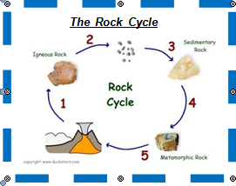 | 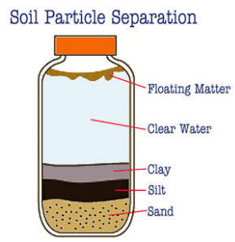  Soil is the thin layer of material covering the earth’s surface and is formed from the weathering of rocks.  Soil is formed of fine rock particles (pieces) mixed with air, water and dead plant and animal matter (organic matter).  The texture of the soil depends on how much clay, silt or sand is in it. | A fossil is the preserved remains or impressions of a living things such as a plant, animal, or insect. A fossil is formed over millions of years.  Studying fossils helps scientists to learn about the past history of life on Earth.  Types of Fossils  Body fossils - Body fossils are fossils where some parts of the organism's body remain as part of the fossil.  Trace fossils - Trace fossils are fossils where there isn't any actual part of the original organism, but "traces" of the organism are preserved in rocks and minerals e.g. footprints.  Fossils are found all over the world. Most fossils are found in sedimentary rock.  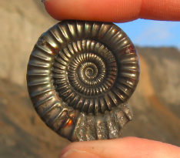  Mary Anning was a famous fossil collector and known for discovering the Ichthyosaurus fossil as well as many others. | Rocks can be permeable or non- permeable.  Something that is permeable means that it allows water to pass through it.  Something that is non-permeable means that it does not allow water to pass through it.  It is important to know whether certain types of rocks are permeable or non-permeable as this can influence the type of rock used for certain things.  For example, when building a roof, a non-permeable rock would need to be used so that water does not leak through. Slate is a rock that is often used.

