Year 4 |  |  |  | Autumn 1 |  |  |  |  | Judaism – Why are they having a Jewish party?
beliefs, teachings and sources |  |  |  | practices and ways of life |  |  |  |  | forms of expression
Key Vocabulary
Judaism - The religion of Jewish people. |  | Jew - A person belonging to the worldwide religion of Judaism. |  |  |  | Synagogue - A building where Jewish people meet to worship or study their religion. |  |  |  | festival - A day or time of year when people celebrate a special event.
celebrate – A joyful occasion for special festivities to mark some happy event. |  | remember - If you remember people or events from the past, you still have an idea of them in your mind and you are able to think about them. |  |  |  | Rosh Hashanah The festival celebrating the Jewish New Year. |  |  |  | shofar - A ram’s horn sounded in the synagogue.
Shanah Tovah –Is said during the festival of Rosh Hashanah and means ‘Good year’. |  | Sukkot - A Jewish festival celebrating the sheltering of the Israelites in the wilderness. |  |  |  | Purim - A festival to remember the Jewish people living in Persia who were saved by the courage of a young Jewish woman called Esther. |  |  |  | sukkah – a temporary home that Jewish people build during the festival of Sukkot
Statutory Words | believe | important |  |  | surprise | special  remember |  | menorah – seven-branch candlestick lit during Hanukkah |  | ancestors - someone from whom you are descended (but usually more distant than a grandparent)
What is Rosh Hashanah?  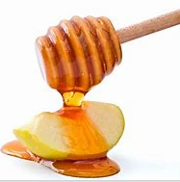  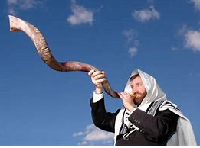  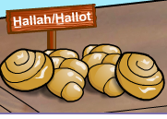 |  |  | 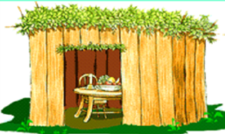  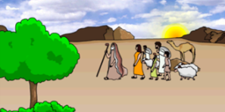  Why Are Jews Remembering At Their Festival of Sukkot? |  |  |  | 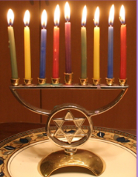  What Are Jews Celebrating At Their Festival of Hanukkah? |  |  |  | 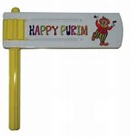  Why Are They Having a Jewish Festival called Purim?
Did you know?  - Rosh Hashanah is the Jewish New Year which is celebrated during early autumn.  - It is a time to think about the way they behave and what they have been like during the last year. They also think about ways to be a better person.  - The shofar is blown in the synagogue.  - There are special foods for Rosh Hashanah. Apples and bread dipped in honey represents a sweet new year to come. Challah bread is often baked into round creations to symbolise the circle of life. |  |  | Did you know?  - Jewish people remember their ancestors who escaped from slavery in ancient Egypt and were on their way to a land of their own – Israel. They had to cross the wilderness and their journey took 40 years.  - The festival of Sukkot dates back 3000 years.  - Jewish people build a sukkah to live in to feel what it might have been like for their ancestors. |  |  |  | Did you know?  - The festival of Hanukkah fallis in winter and lasts for 8 days.  - Jewish people remember a story that happened almost 2200 years ago when ancient Syrians wanted the Jews to give up their religion but the Maccabees ( a group of jewish people) fought back.  - The main celebration is lighting candles or ol lamps every evening.  - This festival is about standing up for yourself, your people and your religion. |  |  |  | Did you know?  - Purim is clebrated in March.  - Jewish people remember the story of Esther, the Jewish woman who married the king of Persia a long time ago. When all the Jews were going to be killed, she acted in a clever and courageous wasy to save them.  - Haman plotted to kill the Jews of Persia.  - The story of Esther is read aloud in the synagogue from a special scroll.

