The Learning objective is: To add the prefix ‘il-‘ before a root word starting with I.
To add the prefix ‘ir-‘ before the root word starting with R
What are prefixes?
Prefixes are a group of letters that change the meaning of a word when they are added to the start.
Activity 1 - Practise the words from your spelling group using the Look Read Cover Write Check method, writing them in your spelling homework book 5 times. We are expecting your very best handwriting too!
Activity 2 – Put the words from your spelling group or the words you found tricky on Monday and write them in a sentence.
On Friday you will be tested on all of the words below. You are expected to get the words in your spelling group correct as well as the statutory words and you can attempt the rest.

Purple  This week purple group will learn to spell the root words | Green | Yellow | Statutory words
legal | illegal | irrational | group
regular | irregular | irrelevant | guard
relevant | irrelevant | illegible | forward
responsible | irresponsible | irresistible | fruit

Extension:
Can you create a paragraph that includes as many of the spelling words as you can?
It can be a funny paragraph but all of the words need to make sense in the sentences that you use them.

The Learning objective is: Alternative spellings for the sound /ee/
Watch the video - Mr Thorne Does Phonics video for alternative /ee/ spellings: https://www.youtube.com/watch?v=WO1ylMaWf0w

Activity 1 - Practise the words from your spelling group using the Look Read Cover Write Check method, writing them in your spelling homework book 5 times. We are expecting your very best handwriting too!
Activity 2 – How many different graphemes can you find for the /ee/ phonemes? Underline them in the passage below. The first one has been done for you.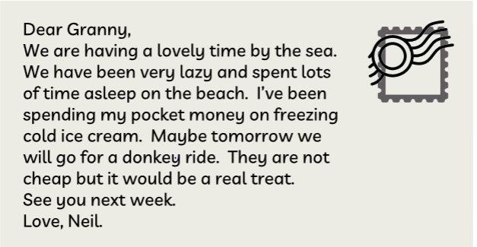
ee | ea | ey | e-e | y | ie
week | please | journey | even | twenty | believe

