Homework:
Hand out date: Friday 9th October
Due in date: Friday 16th October

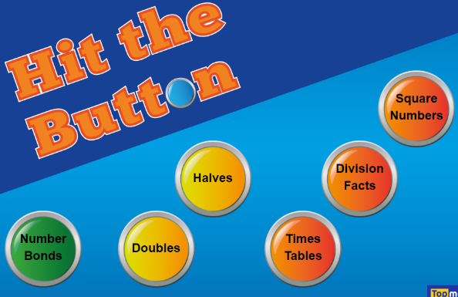
Task One: Arithmetic Task

LO – to recall given times-table.
Search Hit the Button and choose your game.
To challenge yourself, choose division facts.

Task Two: complete the worksheet provided and bring back to school ready to go through and mark in class on a Friday.
LO – to identify lines of symmetry

Video link – https://vimeo.com/436506382
Only watch the video up.

Hand out – 9/10/20
Due in – 16/10/20

