Homework:
Hand out date: Friday 9th October
Due in date: Friday 16th October

Task One: Arithmetic Task
LO - count forwards in steps of 10.
In class this week, we have been looking at counting in steps of 10 from 0.
Choose a multiple of 10 and count forwards. Keep changing your starting number.
Helpful hints:
- All multiples of 10 end in a 0.
- All multiples of 10 are even.
Task Two: complete the worksheet provided and bring back to school ready to go through and mark in class on a Friday.
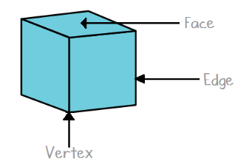
LO – count edges on 3d shapes
Video link –
https://vimeo.com/428007789
Please note the video is the same as last week. This week we are focusing on vertices (vertex).
