Homework:
Hand out date: Friday 16th October
Due in date: Thursday 22nd October

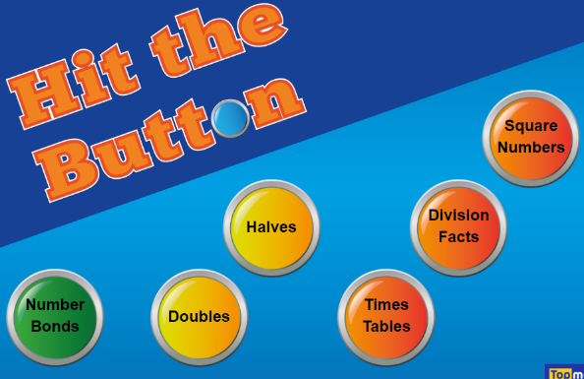
Task One: Arithmetic Task

LO – to recall given times-table.
Search Hit the Button and choose number bonds

Task Two: complete the worksheet provided and bring back to school ready to go through and mark in class on a Friday.
LO – to count vertices on a 3D shape

Video link – https://vimeo.com/428007789
Only watch the video up.

Hand out – 16/10/20
Due in – 22/10/20

