The Learning objective is: spell words with the suffix –ing where the root word has a short vowel sound and the consonant is doubled before adding -ing.

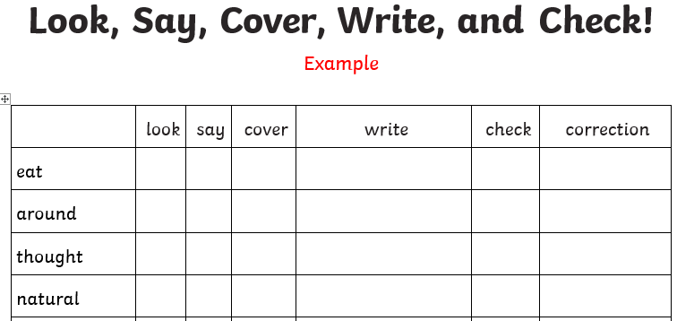
Activity 1 - Practise these words using the Look Read Cover Write Check method, writing them in your spelling homework book 5 times. We are expecting your very best handwriting too!
Activity 2 – Choose 2 of the words from your colour and use them in a sentence.
For example:
I was gripping on to the rope tightly so that I wouldn’t fall.
On Friday you will be tested on all of the words below. You are expected to get the words in your spelling group correct as well as the statutory words and you can attempt the rest.
Purple | Green | Yellow | Statutory words
stopping | clipping | gripping | business
dropping | grabbing | dragging | busy
hopping | planning | dimming | calendar
hugging | grinning | humming | caught

Challenge: can you think of any other –ing words that follow this rule?

