The Learning objective is: spell words with the suffix –ing where we take the ‘e’ off the root word before adding –ing.

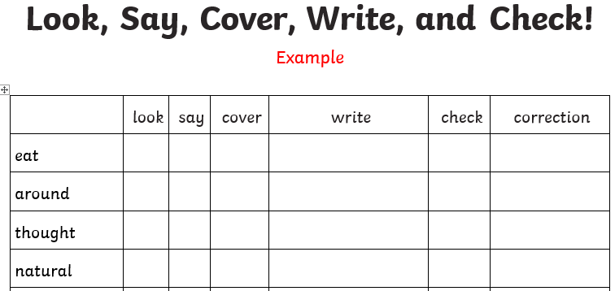
Activity 1 - Practise these words using the Look Read Cover Write Check method, writing them in your spelling homework book 5 times. We are expecting your very best handwriting too!
Activity 2 – Choose 2 of the words from your colour and use them in a sentence.
For example:
I am completing my spelling homework.
On Friday you will be tested on all of the words below. You are expected to get the words in your spelling group correct as well as the statutory words and you can attempt the rest.
Purple | Green | Yellow | Statutory words
using | guiding | experiencing | centre
coming | Imagining | separating | century
having | believing | completing | certain
writing | noticing | exercising | circle

Please note that the root word of the underlined words are also statutory words.
Challenge: can you think of any other –ing words that follow this rule?

