Year 3 Science The Natural world: Bodies are complex systems which need to be taken care of: Animals including humans
Skeleton: Keeps the body in shape, helps movement and protects organs. | Skull: A bone that protects the brain. | Ribcage: A set of bones that protects the heart and lungs. | Heart: A muscle that pumps blood around the body.
Joints: Area where two bones meet | Consumers: Eating food you cannot create yourself. | Muscle: Attached to the bone and are responsible for movement. | Diet: The kinds of food that a person or animal normally eats.
Digest: When food in the stomach is broken down. | Vitamins: Substances found in foods that keep you healthy. | Nutrients: Substances that helps plants and animals to grow. | Organs: Tissues in the body that perform functions.
Human nutrition | Animal nutrition | Human skeleton | Muscles and exercise
Animals, including humans, need the right types and amount of nutrition to keep them healthy. This is called a balanced diet.  Humans cannot make their own food, like plants can, and so they get nutrition from what they eat.  There are 5 main food groups which are fats, minerals, vitamins, proteins and carbohydrates.  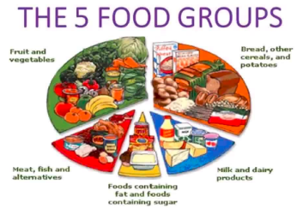  To have a balanced diet means you need to have plenty of fruit and vegetables, bread and other starchy foods. Some milk or diary, meat, fish, eggs and beans as well as a small amount of sugar. | Animals can be grouped according to what they eat into:  Carnivores – feeds on other animals.  Herbivores – feeds on plants and only plants.  Omnivores – feeds on both plants and animals.  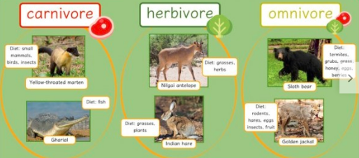  Most mammals are herbivores.  The amount of nutrition and exercise an animal needs depends on the type of animal and what their needs are.  A larger animal will need more nutrients compared to a smaller animal.  The teeth an animal has also depends on which group they are in. A carnivore e.g. a lion has sharp teeth to tear meat. A herbivore has strong, flat teeth for grinding e.g. a horse. | 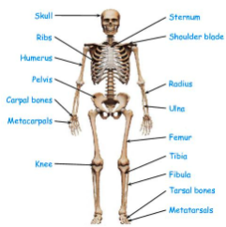  Humans are born with around 270 bones at birth but this total decreases to about 206 bones after some fuse together.  Humans and some other animals need skeletons for support, movement and protection.  Your skull (cranium) is for the protection of your brain.  Your ribs (thoracic basket) is for the protection of vital organs such as the lungs and heart.  Your backbone (spine) is for the protection of your spinal cords and for support. | Muscles are used every time we move. There are more than 600 muscles in the human body.  Muscles are attached to the bone by tendons and work in pairs to allow for smooth movement. To move a joint, one muscle contracts while the other muscle relaxes and becomes longer.  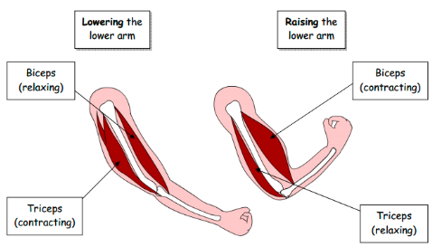  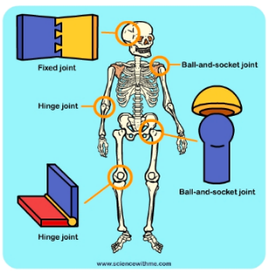  Joints are where two bones meet. They make the skeleton flexible – without them, movement would be impossible. Joints allow our bodies to move in many ways.

