Year 3 |  |  |  |  | R.E Spring 2 |  |  |  |  |  | Why is Easter the most important festival for Christians?
beliefs, teachings and sources |  |  |  |  | practices and ways of life |  |  |  |  |  | forms of expression
Key Vocabulary
Easter: the most important festival of the Christian Church. |  | tomb: the place a dead person would be buried in. |  | Palm Sunday: when Jesus entered Jerusalem. |  |  | Good Friday: The day on which Jesus was crucified. |  | Easter Sunday: when Jesus rose from the dead. |  |  | servant: someone who worshiped and carried out God’s will. |  | disciples: a personal follower of Jesus during his life.
congregation: a group of people assembled for religious worship. |  | resurrection: when Jesus, who had died, came back to life. |  | The last supper: the last meal Jesus had with his disciples. |  |  | salvation: Christians believe Jesus came to earth to ‘rescue’ humans. |  | Mary Magdalene: a friend of Jesus. |  |  | crucifixion: when a person was nailed or bound to a cross. |  | pharisees: a group of Jews who strictly obeyed the laws of Judaism.
Statutory Words | believe |  | promise |  |  | important |  | special |  | guide |  |  | opposite |  | occasion
What happened on Palm Sunday?  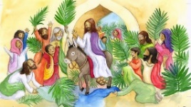 |  |  | What happened at The Last Supper?  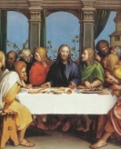 |  |  |  |  | What happened on Good Friday?  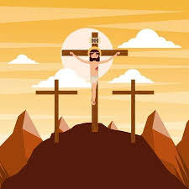 |  |  |  |  | 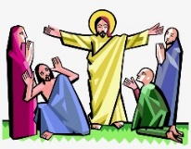  What happened on The First Easter Day?
Jesus asked two of his disciples to go to Jeruseulm to get him a donkey.  When the donkey was brought to Jesus, some of the disciples laid their coats on the donkey’s back as a sign of respect for Jesus.  As Jesus travelled to Jerseulm, people came running towards him and laid their coats on the ground for the donkey to walk over. Some people cut down palm branches and lay them down. More and more people surrounded Jesus because they had heard about him and the amazing things he had been doing.  The people knew that Jesus was special and thought he might be the new King, the person who was going to save them.  The pharisees wanted to be the most important and thought Jesus was getting too much attention.  Many Christian churches provide the congregation with small crosses made from palm leaves at special Palm Sunday services. |  |  | Jesus and his twelve disciples sat to eat a meal. The disciples were worried because some people wanted to kill Jesus.  Then Jesus thanked God and shared some bread and wine with his disciples. The bread and wine represent Jesus’ body and blood.  After the meal, Jesus washed the feet of the disciples and dried them. By washing their feet, he was doing something only a servant would do.  Jesus did this to show the disciples how they should treat others. By doing nice things for others you are being like a servant.  Jesus then told his disciples that Judas would betray him and will turn him over to Pontius Pilate’s soldiers.  The Eucharist is a re-enactment of the Last Supper. The congregation drink a sip of wine and eat a tiny piece of some form of bread. |  |  |  |  | On the day after the ‘Last Supper’ Jesus was taken to the Roman Governor, Pontius Pilate. It was his job to decide what would happen to Jesus.  Pontius Pilate asked the religious leaders if he should release Jesus but they shouted, ‘No! Crucify him!’  Jesus was made to carry his cross through the city to the place where he was to be crucified.  As he carried his cross, he was beaten and mocked by the Roman soldiers.  He was forced to wear a crown of thorns that made his head bleed.  Finally, Jesus was nailed to the cross. He was placed between two thieves who were also being crucified. As Jesus was crucified, darkness covered the land.  The Christian church remembers Jesus dying on the cross for his people by holding a special service. |  |  |  |  | After Jesus died, he was put in a tomb and a heavy stone was rolled in front of the tomb.  Mary (Jesus’ mother) and Mary Magdalene went to see Jesus' body. Suddenly, an angel came down from heaven and told them that Jesus had resurrected from the dead.  They looked in the tomb but it was empty.  Then the angel told them where to find Jesus so the women hurried away to tell the disciples the good news that Jesus was alive.  As they were running, they saw Jesus. They fell to his feet and worshiped him. Jesus told them to tell his disciples to come to Galilee.  The disciples went to Galilee, having heard that Jesus was alive. When they saw Jesus, they were shocked as it was impossible but they were also overjoyed.  The Christian church has a special Sunday service to remember and celebrate the Easter story.

