Year 3 |  |  | R.E Spring 1 |  |  |  | Judaism – what’s it like to live as a Jew?
beliefs, teachings and sources |  |  | practices and ways of life |  |  |  | forms of expression
Key Vocabulary
Abraham - is seen as the father of the Jewish religion. |  | Torah - the most holy Jewish text. |  |  | Shabbat - a day where they can take time out from every day things to feel special. |  |  | synagogue - a building where Jews pray and worship.
covenant - an agreement between God and his people. |  | yad - a pointer is used by the reader when reading the Torah. |  |  | challot - a special bread eaten by Jewish people on a special occasion. |  |  | kippah - a small hat worn by Jewish men.
Statutory Words | believe | promise |  | important | special | guide |  | opposite | occasion
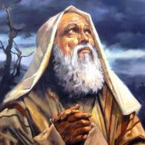  What is Judaism? |  | 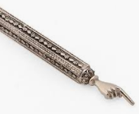  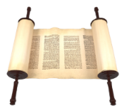  What is the Torah? |  |  | What is the Shabbat?  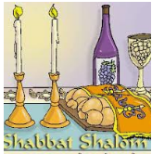 |  |  | 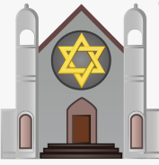  What would I find in a synagogue?
Did you know?  Judaism is the religion of Jewish people. It originated around 4000 years ago.  Jews believe that Judaism began when Abraham began to worship one God instead of the many.  Abraham is seen as the father of the Jewish religion. Abraham’s story is told in the Book of Genesis.  Abraham is said to have made an agreement with God, known as the Covenant, where he promised to be faithful and teach his laws to the world.  The core Jewish religious belief is that there is one eternal God who is a spirit and has no human form. He was an important figure in both Christianity and Islam.  The symbol of the Jewish people is the Star of David. This is similar to the cross being associated with Christianity. |  | Did you know?  The Torah is the most holy Jewish text, given to the Jews by Moses around 1250 B.C and is the first part of the Hebrew (Jewish) bible.  The Torah is written in Hebrew, the oldest of Jewish languages.  The word Torah means ‘teaching’.  It is the central and most important document of Judaism and has been used by Jews through the ages.  When the Torah is not being used, it is kept in a special cupboard at the front of the synagogue called the 'Ark".  The Torah is kept in an ark because it is extremely special and must be looked after.  No one is allowed to touch the Torah so a special pointer called a yad is used to follow words when reading. |  |  | Did you know?  Shabbat is the Jewish day of rest. It begins just before sunset on a Friday night and lasts until after dark on Saturday.  The idea of a day of rest comes from the Bible story where God rested from creating the universe on the seventh day of that first week, so Jews rest from work on the Sabbath.  Jewish people see it as God’s gift to his chosen people as a day where they can take time out from every day things to feel special.  Shabbat is very important to Jewish people: they dress in their best clothes, serve the best food, set the table beautifully and light candles.  Often guests are invited to share food, stories and prayers.  Special loaves of bread called challot are served during Shabbat. |  |  | Did you know?  A synagogue can be used as a place of worship or a place to study for Jewish people.  Often, Jewish men will wear a hat while in the synagogue but as part of their everyday life. It is called a Kippah and is a sign of respect to God.  The Hebrew words of the Ten Commandments are usually written somewhere above the ark.  On top of the ark, there is a light that is always lit which shows that God is always there. It is called the eternal lamp.  Jewish people believe that there should be no images or statues of people's faces in their holy place. Their stained glass windows often show special symbols such as the star of David.  The rabbi leads services in the synagogue.  The word rabbi is Hebrew for 'teacher' because they teach Jews from the Torah.

