Year 3 Science : Light and Shadow
Light: A type of energy that makes it possible for us to see. | Reflector: An object that light bounces back from. | Opaque: Not being able to see through it. | Shadow: A dark area or shape produced by a something blocking light from passing through. | UV Rays: Invisible radiation from the Sun.
Light Source: A source of light makes light. | Reflection: The throwing back light from a surface. | Transparent: Allows light to pass through it so you can see through it. | Surface: An outer layer of an object.
Natural Light: Sources that naturally make their own light e.g. the Sun. | Darkness: The absence of light. | Translucent: Allows some light to pass through. | Sundial: Shows the time by the shadow of a pointer cast by the sun on to a plate marked with the hours of the day.
Sources of Light | Reflectors of Light | How Shadows Are Formed | Size of Shadows | Sun Light and its Dangers
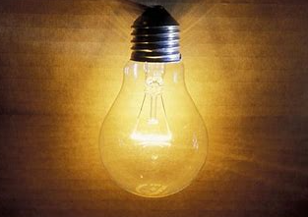  Light is a type of energy that makes it possible for us to see the world around us. A source of light makes light. The Sun and other stars, fires, torches and lamps all make their own light.  Our main natural light source is the Sun. When the Sun is shining on our country, we have daytime but when the Earth spins away from the sun, we have nighttime.  Darkness is the absence of light because light has to reflect from the object to your eye to see it. | 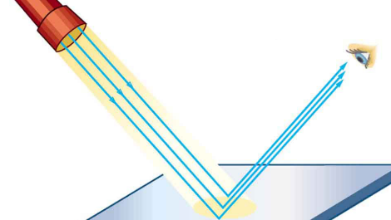  Reflection is when light hits the surface of an object and then that light travels to our eyes so we can see.  When light is reflected by a surface, it changes direction. It bounces off the surface. Smooth, shiny surfaces such as mirrors and polished metals reflect light well. Dull and dark surfaces such as dark fabrics do not reflect light well.  Wearing reflective materials helps other people to see you in the dark. They work by a source of light, such as a torch, lamp or candle, reflecting off of them. | 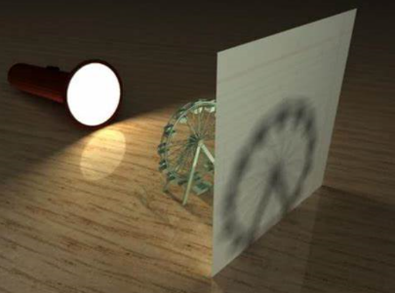  Shadows are dark areas that are created when an opaque (non-see though) object blocks the light source.  Shadows are darkest when the light is shone on opaque surfaces because all the light is being blocked from traveling further.  Transparent and Translucent surfaces cause lighter shadows to form because light can be passed through. | 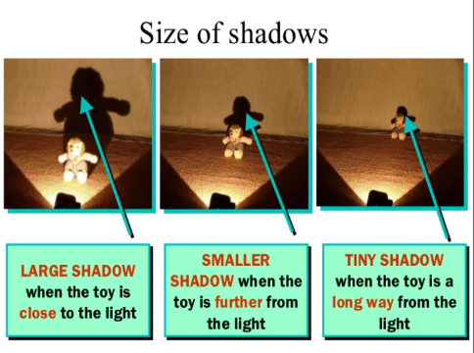  As light moves towards the object, the shadow becomes larger. As light moves away from the object, the shadow becomes smaller. As light moves closer, the shadow becomes longer and wider.  The length of a shadow, that is being created by the Sun, depends on how low or high the Sun is in the sky.  A sundial is a device that tells the time of day when there is sunlight by the position of the Sun in the sky. | 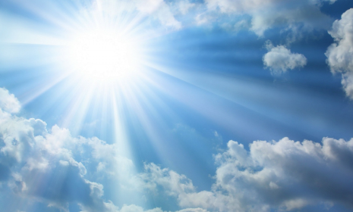  Although sunshine is good for you, it can also be very dangerous.  The sun transmits UV Rays to the earth which can cause damage to your skin.  It is also very dangerous to look directly at the sun as this can damage your eyes.  It is important to stay safe in the Sun by wearing sunglasses, not looking directly at the Sun and covering up.

