The Learning objective is: To learn words ending in -ance
Practise these words using the Look Read Cover Write Check method, writing them in your spelling homework book 5 times. We are expecting your very best handwriting too!
Put each of your coloured spellings in a sentence.
On Friday you will be tested on all of the words below. You are expected to get the words in your spelling group correct as well as the statutory words and attempt the rest.

Purple | Green | Yellow | Statutory words
instance | relevance | abundance | interrupt
distance | hesitance | abundance | determined
brilliance | elegance | reluctance | sacrifice
importance | tolerance | irrelevance | equipped
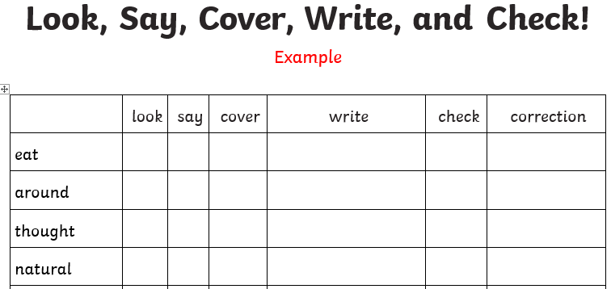
The Learning objective is: To learn words ending in -ance
Practise these words using the Look Read Cover Write Check method, writing them in your spelling homework book 5 times. We are expecting your very best handwriting too!
Put each of your coloured spellings in a sentence.
On Friday you will be tested on all of the words below. You are expected to get the words in your spelling group correct as well as the statutory words and attempt the rest.

Purple | Green | Yellow | Statutory words
instance | relevance | abundance | interrupt
distance | hesitance | abundance | determined
brilliance | elegance | reluctance | sacrifice
importance | tolerance | irrelevance | equipped

