Year 3 |  |  | R.E Summer 2 |  |  |  |  | What is the Importance of the Symbols, Beliefs and Teachings in Hinduism?
beliefs, teachings and sources |  |  |  |  | practices and ways of life |  |  |  |  |  |  | forms of expression
Key Vocabulary
Brahman – the one main God Hindus believe in that has 3 functions known as the trimurti. |  |  |  | Shruti - Hindu holy scriptures which contain the four Vedas (ancient Hindu texts). |  |  |  |  | Mandir - a building where Hindus go to worship. |  |  |  | Murtis – special statues or images of Hindu Gods or Goddesses.
Dharma – to do the right things with good behaviour. |  |  |  | Smirti - Hindu holy scriptures which contain legends, myths and history. |  |  |  |  | Puja – a routine where Hindus pray to a God and give the murtis offerings. |  |  |  | Rakhi – a colourful bracelet made of threads that shows a duty of protection and love.
Statutory Words | believe |  |  | promise |  | important |  |  | special |  | guide |  | opposite |  | occasion
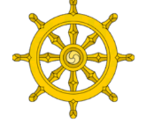  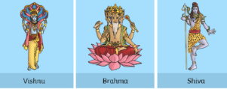  What is Hinduism? |  | What Holy Books do Hindus have?  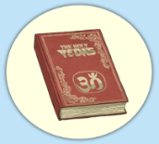 |  |  |  |  | 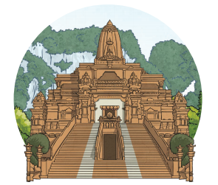  Where do Hindus worship? |  |  | What is significance of the festival Raksha Bandhan?  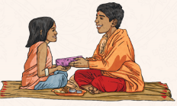 |  |  |  | What is the real meaning of Diwali?  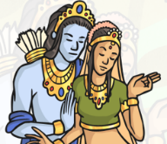
Hinduism is one of the oldest religions. Some say that it started 4500 years ago and it started in the region that is now known as Pakistan.  The Hindu community believe in one main god called ‘Brahman’.  Hindus believe that Brahman (the one God) has three functions and these are shown by the three gods, Shiva, Brahma and Vishnu.  Bahman takes many forms and are sometimes shown as three heads merging into one and are known as the Trimurti.  Hindus believe that there are right and wrong ways to behave. This is called Dharma. It is a complex idea that includes the right behaviour, following the moral law and taking ones duties seriously. |  | Hinduism does not have a single holy book, but several scriptures that they learn knowledge from.  One of the most famous scriptures is the Bhagavad Gita.  These support and guide Hindus in their daily life, within their family and in society. They contribute to the ways Hindus worship.  Hindus have 2 main types of Holy Books. The Shruti (which is heard) and the Smirti (which is remembered).  The Shruti is made up of 4 Vedas. The God Brahma, is believed to have created the 4 Vedas. The Vedas are holy books that were passed on orally for centuries. They contain knowledge from the different Gods.  The Smirti is split into 4 parts. It contains legends, myths and history. |  |  |  |  | Hindus can worship at home or in a Mandir. Some Mandirs are very tall buildings as Hindus believe it brings them closer to heaven.  Each Mandir is dedicated to a God and there will be statues of the Gods inside. These statues are known as murtis. By the statues, there will be a shrine and offerings such as flowers, fruit, water, milk, nuts or sweets are made to the murtis.  Incense is burned to make the Mandir feel special and during worship, Hindus chant the names of their favourite gods and goddesses, sing songs, or just come to be peaceful and pray.  Puja is a daily routine for Hindus and is carried out at least once every day. Most Hindu homes have a holy shrine where puja takes place. |  |  | Raksha Bandhan is a Hindu festival which is sometimes known as Rakhi.  The festival celebrates brotherhood and the love between siblings.  Rakhi is celebrated on the full moon during the month of Shravan in the lunar calendar.  The word ‘raksha’ means protection and ‘bandhan’ means to tie. The rakhi is a bracelet made of coloured threads, often red and gold, woven together with stones and jewels threaded in between.  There is a ceremony where they exchange bracelets, say prayers for their happiness and wellbeing, make a tilak mark on their foreheads and feed each other sweets.  The sister prepares the aarti plate with objects which have special symbolic meaning. |  |  |  | Diwali is another Hindu festival and during this time, the traditional Hindu story of Rama and Sita is told.  The story tells of a famous warrior, Prince Rama, and his beautiful wife, Sita, who were banished from their home by the King.  Living nearby was a terrible demon king called Ravana. He has 10 heads and is feared throughout the land.  When Sita was kidnapped by Ravana,  Prince Rama, with the help of many  animals, searched for his wife. He fought a mighty battle and the whole world rejoiced when Rama eventually killed the evil Ravana, using a magic arrow.  During Diwali, people light lights to show that light triumphs over dark and good triumphs over evil.

