Year 4 | Summer 1 |  | Electricity |  |  |  |  |  | Electricity can only flow in a complete circuit
circuit: A complete route which an electric current can flow around. |  | conductor: Any material that electricity can pass through or along. |  |  | component: part of a circuit such a wires, bulbs, buzzers, motors and batteries. |  |  | electrons: small particles with an electric charge. |  |  | generate: To make or produce.
current: A flow of electricity through a wire. |  | insulator: Any material that electricity cannot pass through or along. |  |  | socket: A device on the wall that you plug electrical equipment into. |  |  | motor: A device that changes electrical energy into movement. |  |  | wire: thin flexible threads that transport electricity.
battery: A small device that stores electrical energy as a chemical. |  | buzzer: An electrical device that makes a buzzing sound. |  |  | appliance: a piece of equipment designed to perform a particular job. |  |  | hazard: something that is dangerous and can hurt. |  |  | cell: A single unit that stores electrical energy as a chemical.
Statutory words |  | accident |  | complete |  | build | probably |  |  | remember | through
What is electricity? |  | Common appliances that run on electricity |  |  | What is a simple series circuit? |  |  | What are conductors and insulators of electricity? |  |  | Common electrical hazards
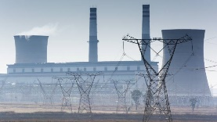  Electricity gives us light, sound, heat and transport. We can't see electricity, but it is all around us.  Electricity is a form of energy.  Everything around us is made up of atoms. Inside every atom there are even smaller particles called electrons. Electricity is a flow of these electrons. This flow of electrons is called the current.  Most of the electricity we use is generated in power stations. The current leaves the power station through power lines and cables, to reach our homes, our schools and our workplaces. This type of electricity is called mains electricity. |  | 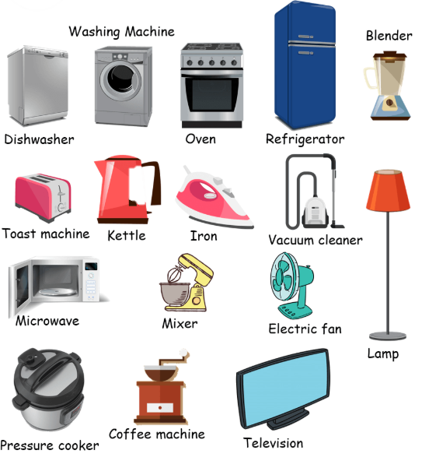  Many every day appliances rely on electricity to make them work. Some appliances need to be plugged into a socket (mains electricity) and others have a battery to make them work. Batteries are used for powering anything that can't be plugged into mains electricity.  Thomas Edison is a famous inventor who invented the lightbulb aND ELECTRIC POWER SYSTEMS THAT ALLOWED THEM TO WORK! |  |  | 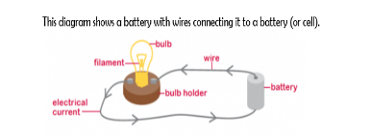  Electricity can flow through the components in a complete electrical circuit. A circuit always needs a power source, such as a battery, with wires connected to both the positive (+) and negative (-) ends. A battery is made from a collection of cells connected together. A circuit can also contain other electrical components, such as bulbs, buzzers or motors, which allow electricity to pass through. Electricity will only travel around a circuit that is complete. That means it has no gaps. You can use a switch in a circuit to create a gap in a circuit. This can be used to switch it on and off. When a switch is open (off), there is a gap in the circuit. Electricity cannot travel around the circuit. When a switch is closed (on), it makes the circuit complete. Electricity can travel around the circuit. |  |  | 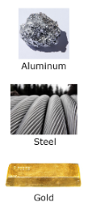  Some materials let electricity pass through them easily. These materials are known as electrical conductors.  Many metals, such as copper, iron and steel, are good electrical conductors.  Metal is used in plugs to allow electricity to transfer from the wall socket, through the plug, and into a device such as a radio or TV.  Some materials do not allow electricity to pass through them. These are known as electrical insulators. Plastic, wood, glass and rubber are good electrical insulators. That is why they are used to cover materials that carry electricity. This stops you from getting an electric shock. |  |  | 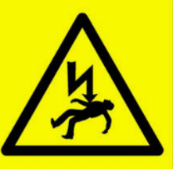  Electricity can be extremely dangerous if it is not used safely.  It can cause burns, shocks, serious injury and (in extreme cases) even death. There are many electrical dangers, both in the home and outdoors.  Common Electrical Hazards  1. Overloading a plug extension socket.  2. Exposed wires.  3. Damaged wall sockets.  4. Wires left along the carpet for people to trip over.  5. Place metal into electrical appliances of electrical sockets.  6. Electrical appliances and wires near water.

