Year 4 |  | Spring 2 |  |  | Living things and their habitats |  |  |  | All living things are connected in some way
species: a group of living organisms |  |  |  | climate: long-term average of weather |  |  | classify: To group together, based on characteristics |  |  |  | vertebrate: animals that have a backbone
habitat: the natural home or environment of an animal or plant |  |  |  | unique: being the only one of its type |  |  | food chain: a series of living beings in which each serves up food for the next |  |  |  | ecosystem: a community of living things, together with their environment
endangered: a species at risk of becoming extinct (when a specie dies out) |  |  |  | deforestation: removal of forest or trees by cutting down |  |  | mammal: animals that do not have a back bone |  |  |  | organism: an individual living thing such as a plant, an animal of bacteria
Statutory words | different |  |  | fruit |  | category | physical |  |  | breathe | environment |  | describe
What are the 7 characteristics of all living livings? |  |  | Why do we need to classify living things? |  |  |  |  | What is a classification key? |  |  |  | 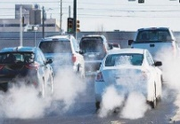  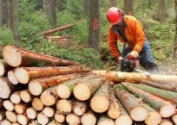  How might a habitat change?
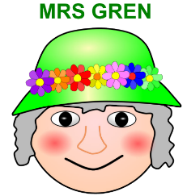  To stay alive and healthy, all living things need certain conditions that let them carry out the seven life.  Processes:  1)Movement – moving, can be fast and obvious or slow and over time.  2)Respiration – releasing energy from food.  3)Sensitivity – responding to their environment.  4)Growth – getting bigger and taller.  5)Reproduction – producing offspring.  6) Excretion – getting rid of waste.  7) Nutrition – taking in food. |  |  | The billions of different kinds of living things (organisms) on earth have been divided up, by scientists, into groups according to their similarities and differences. This is known as classifying.  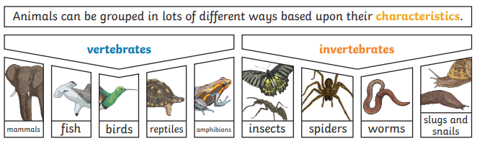  Classifying living things into groups allows scientists to learn more about what makes each species unique. There are many different classes of animal. Those with backbones are known as the vertebrates. These are then grouped into mammals, birds, fish, reptiles and amphibians.  Invertebrates are animals that don't have a backbone. Some have soft bodies, like worms, slugs and jellyfish. Other invertebrates, like insects, spiders and crustaceans, have a hard outer casing called an exoskeleton. This protects their body a bit like a suit of armour.  Plants can be sorted into many different groups. For example: those that flower and those that don’t. |  |  |  |  | 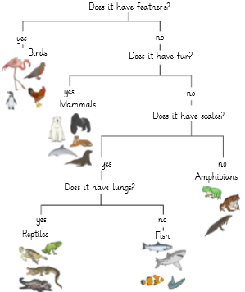  A classification key is a set of yes or no questions about the characteristics of living things. They are used to group and sort animals and plants.  Answer the questions and follow the lines depending on whether the answer is yes or no. |  |  |  | Natural changes: different seasons can change habitats. As the weather changes so can the plant life of the habitat. This can include floodings, droughts, fires and earthquakes.  Human changes: How humans live and what they do can impact habitats both negatively and positively.  Negative ways include deforestation (cutting down trees for a range of reasons). Littering - (dropping rubbish or leaving large objects lying in the environment). Pollution - introducing harmful substances into the environment.  Positive ways include protecting endangered species via conservation projects such as cleaning bodies of water and recycling. Plants and animals rely on the environment to give them everything they need. Therefore, when habitats change, it can be very dangerous to the plants and animals that live there.

