Year 4 R.E Summer Term Christianity : How Did Belief in God Affect The Actions of People in the Testament?
beliefs, teachings and sources |  |  |  |  | practices and ways of life |  |  |  | forms of expression
Key Vocabulary
Old Testament- The first part of the Bible before Jesus’s birth |  |  | belief: an idea accepted as true |  |  |  | wisdom: good understanding of what is true or good |  |  | Judgement- to make a considered decision
Sacrifice- the act of giving something up to show loyalty or deep affection |  |  | devotion: strong loyalty or affections |  |  |  | vocation: a job, career or occupation |  |  | Prophet-a person regarded as a messenger or teacher of God
Patriarch: leaders of family or tribe |  |  | repent: to be sorry or feel remorse for sins |  |  |  | Commandment – an order or law |  |  | Prophecy- a prediction of future events
believe | promise |  |  |  |  | difficult |  | strength |  |  | heard
What is the Old Testament?  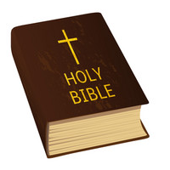 |  | What are some of the stories that can be found in the Old Testament?  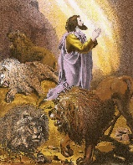 |  |  |  |  | 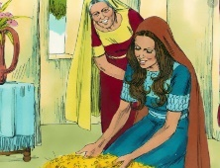  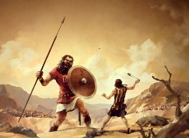  How is strength and self-sacrifice shown in the Old Testament? |  |  | 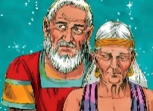  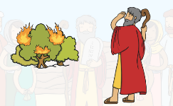  What do the stories of Moses and Abraham teach Christians?
The Christian holy book is called the Bible and that it is also a library of books (history books, law, poetry and wisdom, letters, prophecy and gospels). These books are presented together to make one book – the Bible. The Bible is split into two separate sections, the Old Testament (before Jesus’ birth) and the New Testament (after Jesus’ birth).  The first part of the Bible is called the Old Testament. It is made up of 39 different books which were written between 1200 and 100 BC (before Jesus was born). It contains guidance, instructions, stories and sayings of prophets, inspired by God.  Old Testament contains stories of people whose belief in God affected their actions. These people were called Prophets or Patriachs of God. |  |  |  | The Judgment of Solomon  In a dream, God asks Kings Solomon what gift he would like. And Solomon can choose anything- courage, strength, even money or fame. Solomon chooses an understanding heart and wisdom so he can make good decisions for his people.  Jonah and The Whale: Jonah did not want to follow God’s commandments and did not listen to God. God sent big whale to swallow Jonah and to save him from drowning. While in the belly of the big whale, Jonah asked God for help, repented and praised God.  Daniel and the Lions Daniel did not abandon his beliefs even though they were unpopular among many people. and despite being thrown in the Lion’s den by jealous men. The story of Daniel and the Lions shows his bravery as he is standing up for what he believes in. Christians believe that praying to God helps protect them. |  |  | Strength : Many Christians are inpsired by the actions of David in the story David & Goliath. David heard the giant Goliath mocking God and his beliefs. He persuaded King Saul to let him fight . Without any armour, he gathered 5 stones and killed the Giant with 1 stone. Christians believe that with God on your side you can have the strength to overome anything Self-sacrifice: The Story of Ruth Naomi and Ruth (daughter in- law) had both lost their husbands and moved back to Bethlehem. Ruth said, ‘Where you go I shall go..You’re God will my my god’. The friends arrived in Bethlehem with nothing. God had an amazing plan for Ruth who worked tirelessy in the fields to provide for Naomi and showed the virtues of friendship, hardwork and self-sacrifice. |  |  | Moses and the Burning Bush:  In this story, Moses hears the voice of God from a burning bush. God asked Moses to lead his people out of slavery to the Promised Land.  Christians believe that are called by God to be better Christians in every aspect of their lives. Vocation does not necessarily mean paid work.  The story of Abraham  Abraham’s decision to follow God impacted on him and his family. Abraham believed and trusted God, and from there, Sarah trusted him too. God wanted Abraham and his family to move. That was scary as Abraham had to leave a place he knew. He would have to trust in God and he did. God promised them children. This reminds Christians that God wants the best for everyone.

