Year 4: Rainforest
locational and place knowledge |  | human and physical knowledge |  |  |  |  | place knowledge |  |  | Geographical skills and fieldwork
canopy: one of the Upper layers of the rainforest | vegetation: plant life of a region |  |  |  | understory: a layer of vegetation beneath the canopy |  |  | temperatures: is the degree of hotness or coldness |  |  |  | indigenous: the first people who lived in any region
continent: a continent is a large solid area of land. Earth has 7 continents | the tropics: the region of Earth’s surface that is closest to the equator |  |  |  | equator: an imaginary line around the middle of the earth equal distance from the north and South Poles |  |  | deforestation: the large-scale removal of trees from a forested area to allow the land to be repurposed |  |  |  | species: group of living things
forest floor: lowest layer of rainforest where it is dark, hot and damp | tropical climate: areas that are warm and wet and located near the equator |  |  |  | temperate zone: areas of earth that are between the tropics and the polar circles |  |  | climate: the general weather conditions of an area |  |  |  | emergent layer: top layer of the rainforest
What are rainforests and where are they located? |  |  | What is the weather and climate of rainforests? | What are the features of a rainforest? |  | What lives and grows in a rainforest? |  |  | What groups of people live in rainforests and why? |  | What are the causes and effects of deforestation?
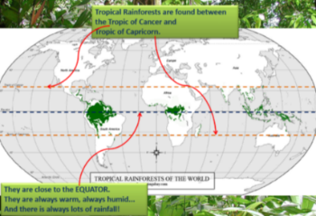  Rainforests are found on every continent across the Earth, except Antarctica.  Tropical rainforests are found close to the equator where temperatures and rainfall are very high all year round. The major areas of tropical rainforests are in South East Asia, West Africa and South and Central America. The best known rain forests are found in tropical regions between the Tropics of cancer and Capricorn.  Temperate rainforests are found along coasts in the temperate zone. The largest temperate rainforests are found on North America's Pacific Coast and stretch from Northern California up into Canada. Temperate rainforests have one long wet winter/spring season, and a dry foggy summer. |  |  | There are two types of Rainforest:  Temperate Rainforests: Found in the temperate climate zone (above and below the Tropic of Cancer and Capricorn.  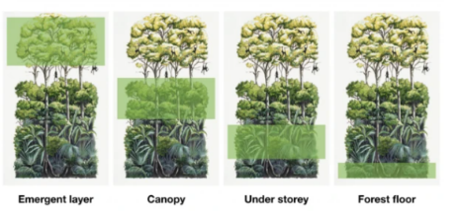  Tropical Rainforests: Found between the Tropic of Cancer and the Tropic of Capricorn.  Emergent Layer - very sunny because it is the very top. Only the tallest trees reach this level.  Canopy Layer - much of the rain is stopped by the thick foliage.  Understory Layer - many vines, dense vegetation, not much light.  Forest Floor - dark, damp, full of many dead leaves, twigs and dead plants. |  |  | 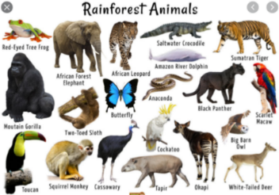  Around two-thirds of the world’s plant species live in rainforests. Rainforest conditions are perfect for helping plants grow. There are thousands of different species of flowers, trees and other plants. Different rainforests around the world have different animals, for example elephants don’t live in the rainforests of South America as they live in the rainforests of Africa, southeast Asia and India.  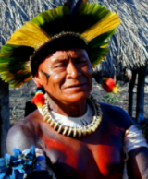  Rainforest plants are used to make lots of the things we use every day, such as coffee, cacao (for chocolate), rubber, wood and dye.  Rainforests are also home to groups of people called tribes. These people are indigenous to the area and are self-sufficient, using only natural resources found in the rainforest. The South American Yanomani tribe consists of around 35.000 people. Some of these tribes have had little contact with the outside world. |  |  |  |  | Deforestation is when the trees in a forest are cut down. This can be done for many reasons, such as clearing an area for farming, logging for wood, mining, settlement and roads.  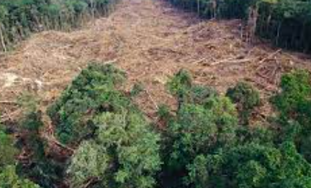  Deforestation also threatens the survival of many species of plants and animals due to a loss of habitat. With nowhere to live and less food to hunt or eat, species can become extinct.

