Year 4 | Spring 1 |  |  | Sound |  |  |  | Energy: Light and sound travel in waves and reflect off objects
vibration/vibrates: when something shakes back and forth |  | frequency: the number of vibrations per second |  |  | sound waves: a steady, flowing movement of vibrations |  | louder: a high volume of sound |  |  | muffle: to dull or reduce the sound of something
pitch: how high or low a sound is |  | volume: how loud or quiet something is |  |  | fainter: getting quieter |  | ear: the organ in the body from which humans hear |  |  | vacuum: a space where there is no matter
source: the place where a sound  is being made |  | hear: to take something in through the ear |  |  | energy: natural power |  | absorb/absorbing: to take in or soak up |  |  | particles: tiny bits of matter that make up everything in the universe
Statutory words |  | through | recognise |  | natural | experiment | material |  | heard | equipment |  | describe
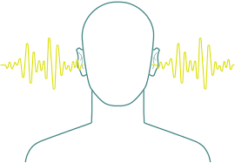  What is sound? |  | How does sound travel? |  |  | 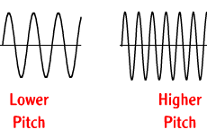  What is pitch? |  | What is volume? |  |  |  | 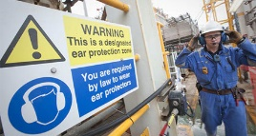  What are the dangers of sound?
Sound is a form of energy.  When something makes a sound, the sound energy flows away from the source in waves.  Every sound we hear is made by an object vibrating (shaking back and forth).  As the object vibrates, it pushes the air around it making the air vibrate too.  These vibrations, which are called sound waves, move by squeezing and stretching, like a spring.  The sound is travels through the air to our ears in little vibrations, which we hear as sound. |  | Sound waves can travel through solids and liquids as well as air; in fact, they travel faster through a solid and a liquid than air.  Sounds travel in all directions which is why you can hear a noise if the source is above you, below you, behind or in front of you.  When there are no particles, as in a vacuum, sound cannot travel at all. No sound can be heard in space.  Sound travels much slower than light so an aircraft can be seen before the noise of its engines is heard. |  |  | The pitch of a sound is how high or low the sound is. A high sound has a high pitch and a low sound has a low pitch.  A tight drum skin gives a higher pitched sound than a loose drum skin.  The rumble of a lorry makes a low-pitched sound. This is because the sound waves are long.  The squawk of a parrot makes a high-pitched sound. This is because the sound waves are short. |  | The volume of a sound how quiet or loud it is.  If we remember that sound is a form of energy, then a whisper is a low-energy sound. It can only be heard a few metres away.  The high-energy sound from a rocket travels a lot further. High-energy sounds travel further than low-energy sounds.  A thunderclap has an enormous amount of energy. It can be heard from many kilometres away, hopefully giving you enough time to take shelter before the thunderstorm arrives.  The volume of a sound can become fainter as the distance from the sound source increases. |  |  |  | If someone can hear the music coming through the earphones you are wearing, then the music is too loud and may be damaging your ears.  People who work with noisy engines like tractors, farm and factory machinery should wear earmuffs to protect their hearing so you need to stay away from them to protect yours  Earmuffs block sound by absorbing the vibrations and stopping them from reaching the eardrum. They are usually made from soft, bulky material that is good at absorbing vibrations.

