Year 4 |  |  |  | Summer term |  |  |  |  |  | The Tudors
Conflict and resolution |  |  | Leadership |  |  |  | Lifestyle |  |  |  |  | Technology
dynasty- a line of rulers by birth |  |  | monarch- a head of state (ruler) such as a King, Queen or Emperor |  |  |  | defeat- having been beaten in battle or other contest |  |  |  |  | peasant- a farm or farm worker who owns very little and considered poor
reign- to rule as King or Queen |  |  | annul- to cancel by law |  |  |  | legacy- memories or knowledge that is left behind |  |  |  |  | navy- armed forces at sea
civil war- a war between two families who wanted to take the throne |  |  | heir- a person who has legal claim to a throne or title |  |  |  | dissolution- the act of breaking up (to close down officially) |  |  |  |  | monastery- a building where people lived and worshiped, devoting their time to God
Statutory Words | century |  |  |  | eighth |  |  | famous |  |  | popular |  |  | remember
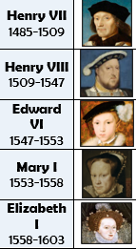  Conflict & resolution  Who were the Tudors? |  | Leadership  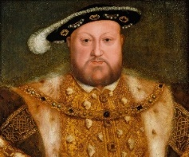  Who was King Henry V111? |  |  |  | Technology  What did the Tudors leave behind for us?  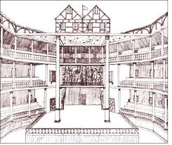 |  |  | Lifestyle  What was Tudor life like for a child?  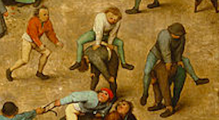 |  |  |  | 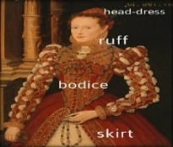  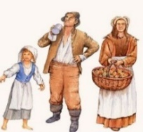  Lifestyle
The Tudor dynasty was a series of kings and queens of England. This line of rulers started in 1485 and lasted until 1603. The dynasty started when Henry Tudor defeated Richard III at the Battle of Bosworth Field.  This was the last main battle in the ‘War of the Roses’, a civil war between rival families in the House of Lancaster and York.  The battle was won by the Lancastrians and Henry Tudor became the first King of the Tudor period. Richard of York had been an unpopular King and so Henry took his chance to take the throne. |  | Henry V111 became the King of England at 17 years old in 1509. He grew up as a Catholic but established the Protestant Church of England when the Pope (head of the Catholic Church) wouldn’t let him annul his first marriage to Catherine of Aragon. Between 1536-1540 Henry VIII ordered the dissolution of the catholic monasteries. He gave land and money to people who supported him. He was a powerful man who had 6 wives!  Henry VIII loved hunting, playing games like tennis, dancing and reading. He also loved eating and became very fat as he got older and couldn’t exercise as much.  Henry loved luxury – he was very well dressed, and wore velvet robes with gold trim and jewels, and rebuilt and redecorated his rooms at Hampton Court Palace at least 6 times! Hampton Court was the most modern, sophisticated and magnificent palace in England. |  |  |  | The first purpose-built theatre opened in 1570 during the reign of Elizabeth 1^{st.} Many plays from this time have survived and you can still see them acted today. William Shakespeare was a celebrated playwright during this time.  In the Tudor period we begin to see portrait painting for the first time. Images of Kings and Saints fill churches but they did not often show their true likeness as they paid the artist to paint them to look as nice as possible!  The Tudor dynasty built up a very powerful navy which helped Britain to defend itself from those who wanted to attack. |  |  | In Tudor times, childhood was often unpleasant and short-lived. It was believed that physical punishment was an important part of bringing up children, both at home and at school. Noble girls could be married as early as 12 and boys at 14.  From the age of just seven, some children left home to become apprentices or servants in rich people’s houses. Apprentices, who were mostly boys, were tied to their master by a strict oath (promise), and provided with a place to stay, food to eat and the necessary clothes and tools. The apprentice assisted his master at work, gradually picking up a trade.  Toys were often made from wood or materials easily available such as clay, stone and animal bones. Pig bladders were blown up to make footballs, hoops were made from old barrels and pebbles were used to play marbles or jacks. |  |  |  | Tudor England is famous for its beautiful and ornate clothing, particularly during the reign of Queen Elizabeth I.  Clothes were a means of displaying how wealthy a person was. Rich people could afford clothing made of fine wool, linen or silk. Their clothes were decorated with jewels and embroidered with gold thread.  Items like a ruff gave a strong signal about the wealth and importance of the person wearing it.  Tudor peasants and the poor wore loose-fitting clothes which were made from woollen cloth. Men would wear a tunic to their knees and women often wore an apron.

