Year 4 |  |  | Spring term |  |  |  | The Vikings: Invaders and Settlers
Conflict & resolution |  |  | Leadership |  |  | Lifestyle & religion |  |  | Technology
Vikings: means ‘pirate raid’ but were a group of people from Norway, Sweden and Denmark |  |  | Danelaw: the area in Britain the Vikings ruled |  |  | longboat: a boat used by the Vikings to raid Britain |  |  | Battle of Hastings: the battle that saw the end to the Anglo-Saxon and Viking rule
invasion: an occasion when an army enters a country and attacks it |  |  | raids: a surprise attack |  |  | armies: an organized military force equipped for fighting |  |  | Alfred the Great: an Anglo-Saxon King who made a peace agreement with the Vikings
monastery/ies: a building where people devote themselves to God |  |  | Lindisfarne: a small island (was a sacred Christian place) the Northern Coast of England where the Vikings raided |  |  | reign: the period of rule of a King or Queen |  |  | Scandinavia: an area that is made up of the countries Denmark, Norway and Sweden
Statutory Words | group |  | guard | possession |  | surprise |  |  | island | arrive
Conflict & Resolution  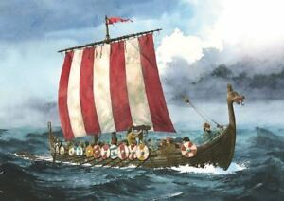  Who were the Vikings? |  | Conflict & Resolution  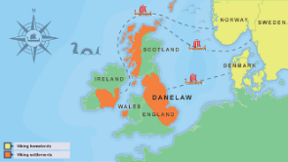  What was the biggest Viking invasion? |  |  | 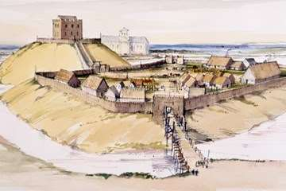  Lifestyle What was life like in the Danelaw? |  |  | Leadership  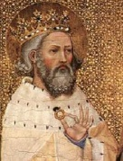  Who was Edward the Confessor?
The Viking age in European history was from about AD700 to 1100.  During this period, many Vikings left their homelands in Scandinavia and travelled by longboat to other countries, like Britain and Ireland.  The Vikings fought the local people, stealing from churches and burning buildings to the ground. Monasteries were often targeted, for their precious silver, gold chalices, plates, bowls and crucifixes.  These ruthless pirates continued to make regular raids around the coasts of England, looting treasure and other goods. They made surprise attacks on places like Lindisfarne.  There was no English navy to guard the coasts so it was easy for small groups of Vikings to land on a beach or sail up a river. It was not long before larger Viking armies began attacking Britain. |  | In time, Vikings made their home in Britain. In AD865 an army of Vikings sailed across the North Sea. This time they wanted to conquer land rather than just raid it. Over several years the army battled through northern England, taking control of the Anglo-Saxon kingdoms of Northumbria, East Anglia and most of Mercia.  By AD874, almost all the kingdoms had fallen to the Vikings. All except for Wessex, which was ruled by Alfred the Great. King Alfred beat the Viking army in battle but wasn't able to drive the Vikings out of Britain.  After years of fighting the Vikings and Alfred made a peace agreement but even after this agreement, fighting went on for many more years. An imaginary dividing line was agreed to run across England, from London in the south towards Chester in the north west.  The Anglo-Saxon lands were to the west and the Viking lands, known as the Danelaw, were roughly to the east. |  |  | Vikings travelled from Scandinavia to Britain. They mostly settled in the Danelaw, to the north and east of England.  Some Norwegian Vikings or 'Norse' sailed to Scotland. They made settlements in the north, and on the Shetland and Orkney Islands.  Vikings also settled on the Isle of Man and often raided Wales, but few made homes there. In Ireland, the Vikings founded the city of Dublin.  The Danelaw covered an area east of their line joining London and Chester. Everything to the east belonged to the Vikings.  The most important city in the Danelaw was the city of York, or ‘Jorvik’ as the Vikings knew it. Over 10,000 people lived there and it was an important place to trade goods. Many towns and cities in Britain that were founded by the Vikings can still be spotted today. |  |  | The last but one of the Anglo- Saxon kings of England, Edward was known for his religious faith (he is known as 'the Confessor' because of his life was characterised by piety and religious belief).  Edward spent almost twenty-five years in Normandy and when he became King many of his closest advisors were Normans. Many people in England did not like the close relationship that Edward had with the Normans and so fights broke out.  Although England was quiet and relatively peaceful and prosperous during his reign, his failure to leave an heir led to the Norman invasion of England in 1066.  The Battle of Hastings in 1066 brought an end to the Anglo-Saxon and Viking rule and led to the last major invasion in British History.  William I (known as William the Conqueror) became the first Norman King after his victory at the Battle of Hastings in 1066.

