Year 4 |  |  |  |  | Autumn 1 |  |  |  |  | Judaism – Why are they having a Jewish party?
beliefs, teachings and sources |  |  |  |  | practices and ways of life |  |  |  |  | forms of expression
Key Vocabulary
Judaism - the religion of Jewish people. |  |  | Jew - a person belonging to the worldwide religion of Judaism. |  |  |  |  | Shanah Tovah – is said during the festival of Rosh Hashanah and means ‘Good year’. |  |  | festival - a day or time of year when people celebrate a special event.
celebrate – a joyful occasion for special festivities to mark some happy event. |  |  | sukkah – a temporary home that Jewish people build during the festival of Sukkot. |  |  |  |  | Rosh Hashanah - the festival celebrating the Jewish New Year. |  |  | shofar - A ram’s horn sounded in the synagogue.
Synagogue - A building where Jewish people meet to worship or study their religion. |  |  | Sukkot - A Jewish festival celebrating the sheltering of the Israelites in the wilderness. |  |  |  |  | Purim - a festival to remember the Jewish people living in Persia who were saved by the courage of a young Jewish woman called Esther. |  |  | remember - if you remember people or events from the past, you still have an idea of them in your mind and you are able to think about them.
Statutory Words | believe | special | important |  |  | surprise | remember | menorah – seven-branch candlestick lit during Hanukkah. |  |  | ancestors - someone from whom you are descended (but usually more distant than a grandparent).
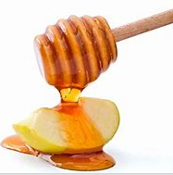  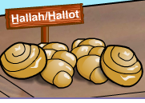  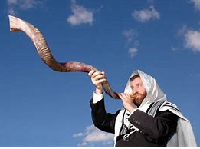  What is Rosh Hashanah? |  |  |  | 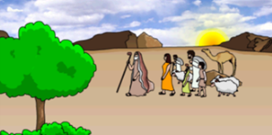  Why Are Jews Remembering At Their Festival of Sukkot?  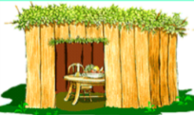 |  |  |  |  | 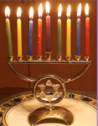  What Are Jews Celebrating At Their Festival of Hanukkah? |  |  | 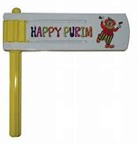  Why Are They Having a Jewish Festival called Purim?
Rosh Hashanah is the Jewish New Year which is celebrated during early autumn.  It is a time to think about the way they behave and what they have been like during the last year. They also think about ways to be a better person.  The shofar is blown in the synagogue.  There are special foods for Rosh Hashanah. Apples and bread dipped in honey represents a sweet new year to come. Challah bread is often baked into round creations to symbolise the circle of life. |  |  |  | Jewish people remember their ancestors who escaped from slavery in ancient Egypt and were on their way to a land of their own – Israel.  They had to cross the wilderness and their journey took 40 years.  The festival of Sukkot dates back 3000 years.  Jewish people build a sukkah to live in to feel what it might have been like for their ancestors. |  |  |  |  | The festival of Hanukkah falls in winter and lasts for 8 days.  Jewish people remember a story that happened almost 2200 years ago when ancient Syrians wanted the Jews to give up their religion but the Maccabees (a group of jewish people) fought back.  The main celebration is lighting candles or ol lamps every evening.  This festival is about standing up for yourself, your people and your religion. |  |  | Purim is clebrated in March.  Jewish people remember the story of Esther, the Jewish woman who married the king of Persia a long time ago. When all the Jews were going to be killed, she acted in a clever and courageous wasy to save them.  Haman plotted to kill the Jews of Persia.  The story of Esther is read aloud in the synagogue from a special scroll.

