` Year 4 |  |  |  | R.E Summer Term |  |  |  |  | Islam- What does it mean to be a Muslim?
beliefs, teachings and sources |  |  |  | practices and ways of life |  |  |  |  | forms of expression
Key Vocabulary
A mosque – A Muslim place of worship |  | Islam – second most popular religion in the world |  |  |  | prophet – messenger of Allah |  |  |  | Salah – Muslim prayer
Qu’ran – The holy book of Islam |  | Muslim - a follower of the religion Islam |  |  |  | Muhammed (Pbuh)- the last prophet of Allah and the founder of Islam |  |  |  | Ritual- a series of religious actions
Allah– The Arabic name that Muslims use for God |  | Adhaan- A type of Muslim prayer |  |  |  | Arabic-a language |  |  |  | Mecca- An important place to Muslims. It is where Muhammed was born
believe | promise |  |  |  | difficult |  |  | strength |  |  | heard
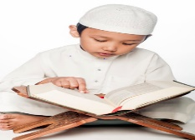  Why is the Qu’ran special to Muslims? |  |  | 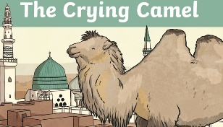  What do stories teach us about Muslim beliefs? |  |  |  | How are Muslim babies welcome in to the world ?  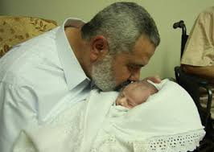 |  |  | How do Muslims pray?  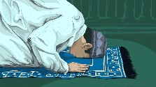
-The Qu’ran is the holy book of Islam. Islam is A way of life taught by Allah and the followers of Islam are known as Muslims. The Qu’ran is a book in the Arabic language that Muslims believe to be the actual words of Allah.  - In the Qu’ran, Allah tells Muslims how they should worship him and how they should behave towards each other. The Qu’ran is a collection of signs of Allah’s existance and instructions for how Muslims should live their lives.  -The Qu’ran becomes part of a Muslim’s life from an early age. Chidlren learn to read it at home or by attending Islamic school after their regular school day and at weekends/ There are many ways children can learn the Qu’ran and also learn about the Prophet Muhammed ( pbuh). |  |  | -The prophet Muhammad was the founder of the religion of Islam. Followers of Islam, believe that Muhammad received messages from Allah (God). These messages were later collected into the Qu’ran the holy book of Islam.  - Muslims believe that Muhammad (pbuh) is the final prophet of Allah. The prophet Muhammed (pbuh) is seen as a source of moral and religious teaching and guidance for Muslims and so there are many stories about him  -One particular story, The Crying Camel teaches Muslim’s to show kindness and respect for all Allah’s creatures |  |  |  | Muslims have some very simple rites for welcoming a child.  The Muslim call to prayer or Adhaan ("God is great, there is no God but Allah. Muhammad is the messenger of Allah. Come to prayer.") are the first words a newborn Muslim baby should hear. They are whispered into the right ear of the child by his or her father.  The baby's first taste should be something sweet, so parents may chew a piece of date and rub the juice along the baby's gums. It was a practice carried out by the Prophet Muhammed and is believed to help tiny digestive systems to kick in. |  |  | Salah is the Arabic word for prayer  Muslims can pray anywhere, it doesn’t have to be in a Mosque. But no matter where, Muslims must face towards Mecca.  -Before Muslims pray, they make an intention to Allah. This helps to remember that God is in front of them and is listening.  Muslims use a prayer mat to kneel down to pray. only the palm, knees and forehead touch the ground. This helps focus the body and mind on Allah  -At the end of the prayer, Muslims bless the angels that keep an eye on those who follow Islam.  -The Muslim prayer is performed 5 times a day by millions of Muslims all over the world and helps to connects them to Allah and other followers of Islam.

